**ELECTRICITY ENERGY THEFT DETECTION IN SMART GRIDS USING DEEP NEURAL NETWORKS**

**A project report submitted in partial fulfillment of the requirement for the award of the degree of**

**BACHELOR OF TECHNOLOGY**

**in**

**COMPUTER SCIENCE & ENGINEERING**

**of**

**JAWAHARLAL NEHRU TECHNOLOGICAL UNIVERSITY ANANATPUR, ANANTHAPURAMU.**

**by**

**D K KRISHNA MOHAN 202K1A0515**

**J RANJITH KUMAR 202K1A0527**

**LAMBADE VENKATESH 202K1A0535**

**ARCOT NAVEEN 202K1A0504**

**M VINOD KUMAR 202K1A0536**

**M RAVI KIRAN 20HU1A0566**

**Under the esteemed guidance of**

**B. HUSSAIN M. Tech.**

**Associate Professor**

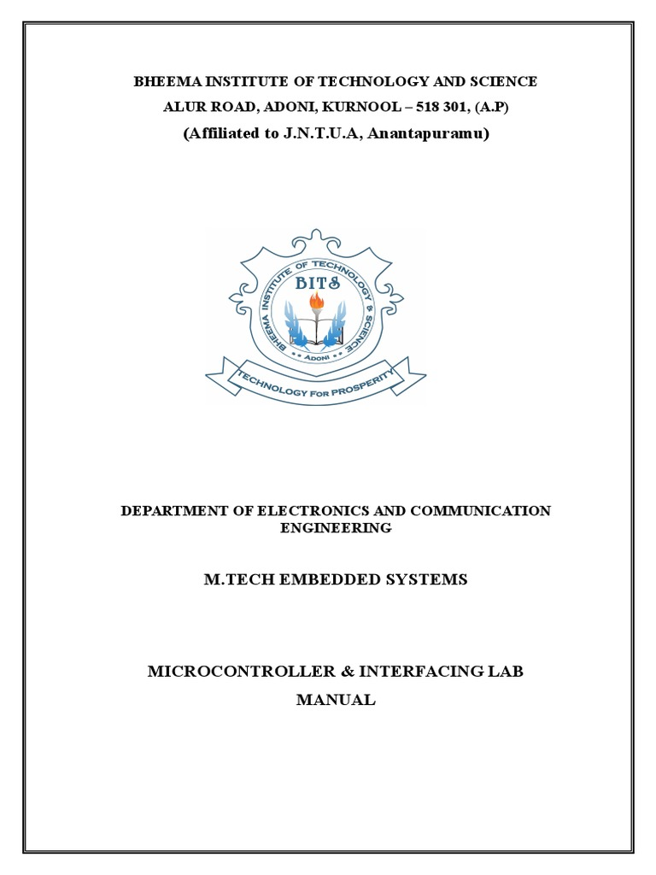

**DEPARTMENT OF COMPUTER SCIENCE & ENGINEERING**

**BHEEMA INSTITUTE OF TECHNOLOGY AND SCIENCE**

**Alur Road, Adoni-518301, Kurnool, Andhra Pradesh**

**(Affiliated to Jawaharlal Nehru Technological University Anantapur, Ananthapuramu)**

**2020-2024**

**BHEEMA INSTITUTE OF TECHNOLOGY AND SCIENCE**

**Alur Road, Adoni – 508301**

(Affiliated to Jawaharlal Nehru Technological University Anantapur, Ananthapuramu)



**DEPARTMENT OF COMPUTER SCIENCE & ENGINEERING**

**CERTIFICATE**

This is to certify that the project entitled “**ELECTRICITY ENERGY THEFT DETECTION IN SMART GRIDS USING DEEP NEURAL NETWORKS”** being submitted by **D K KRISHNA MOHAN (202K1A0515), J RANJITH KUMAR (202K1A0527),LAMBADE VENKATESH (202K1A0535), ARCOT NAVEEN (202K1A0504), M VINOD KUMAR (202K1A0536), M RAVI KIRAN (20HU1A0566).** in partial fulfilment of the requirement of the award of degree of Bachelor of Technology in Computer Science & Engineering of Jawaharlal Nehru Technological University Anantapur, Ananthapuramu during the academic year 2020-2024.

**B.HUSSAIN Dr. D. William Albert**

**Project Guide Head of the Department**

Place: Adoni

Date:

Certified that the candidate was examined by me in the viva-voice examination held at Bheema Institute of Technology & Science, Alur Road, Adoni on _____________________.

**INTERNAL EXAMINER EXTERNAL EXAMINER**

**ACKNOWLEDGEMENT**

We take this opportunity to thank all those magnanimous persons who rendered their full support to our work the pleasure, the achievement, the glory, the satisfaction, the reward, appreciation and the construction of this regular schedule spared their valuable time for us. This acknowledgement is not just a position of words but also an account of indictment. They have been guiding and source of inspiration towards the completion of this project.

We express our gratitude to **G. S. SURENDRA BABU**, principal, Bheema Institute of Technology and Science, Adoni, for giving us an opportunity to do this project work.

We also like to express our sincere gratitude and special thanks to Associate professor **Dr. D. William Albert,** Head of the Department of Computer Science and Engineering for his guidance and support towards the completion of this project.

We are thankful to our guide **B. HUSSAIN M. Tech, Associate professor**, who with his continuous efforts, unfailing interest, constant support and providing me the right infrastructure helped me in completing this project work.

We would like to thank all the faculty members of CSE department and our friends for their valuable suggestions and support which directly or indirectly helped us in mounding this project in to a comprehensive one.

We wish to express our gratitude to our parents, whose love and encouragement have a great support throughout our education.

**STUDENT NAME REGISTRATION NUMBER**

**D K KRISHNA MOHAN 202K1A0515**

**J RANJITH KUMAR 202K1A0527**

**LAMBADE VENKTESH 202K1A0535**

**ARCOT NAVEEN 202K1A0504**

**M VINOD KUMAR 202K1A0536**

**M RAVI KIRAN 20HU1A0566**

**ABSTRACT**

Electricity energy theft is a global problem that negatively affects both utility companies and electricity users. It destabilizes the economic development of utility companies, causes electric hazards and impacts the high cost of energy for users. The development of smart grids plays an important role in electricity energy theft detection since they generate massive data that includes customer consumption data which, through machine learning and deep learning techniques, can be utilized to detect electricity theft. This paper introduces the theft detection method which uses comprehensive features in time and frequency domains in a deep neural network-based classification approach. We address dataset weaknesses such as missing data and class imbalance problems through data interpolation and synthetic data generation processes. We analyze and compare the contribution of features from both time and frequency domains, run experiments in combined and reduced feature space using principal component analysis and finally incorporate minimum redundancy maximum relevance scheme for validating the most important features. We improve the electricity energy theft detection performance by optimizing hyper parameters using a Bayesian optimizer and we employ an adaptive moment estimation optimizer to carry out experiments using different values of key parameters to determine the optimal settings that achieve the best accuracy. Lastly, we show the competitiveness of our method in comparison with other methods evaluated on the same dataset. On validation, we obtained 97% area under the curve (AUC), which is 1% higher than the best AUC in existing works, and 91.8% accuracy, which is the second-best on the benchmark.

**CONTENTS**

**Chapter 1:** INTRODUCTION 1-3

1.1 Introduction 1

1.2 The Contributions of our project 2

**Chapter 2:** LITERATURE SURVEY 4-82.1 Electricity energy theft detection using pipeline in machine learning 4

2.2 Wide and deep convolution neural networks for electricity-theft detection to secure smart grids 4

2.3 Smart grid – The new and improved power grid: A survey 5

2.4 Efficient detection of electricity energy theft cyber attacks in

AMI network 5

2.5 Tackling energy theft in smart grids through data driven-analysis 6

2.6 Progress and challenges in smart grids: Distributed generation,

Smart metering energy storage and smart loads 6

2.7 Minimizing household electricity energy theft in Nigeria using GSM based meter. 7

2.8 Power theft detection & initiate energy meter information through SMS with auto power cut off. 7

2.9 Prototype development to detect electric theft using PIC18F452 microcontroller. 8

**Chapter 3:** SYSTEM ANALYSIS 9-16

3.1 Existing system 09

3.2 Disadvantages in Existing System 10

3.3 Proposed system 10

3.4 Advantages of Proposed system 11

3.5 Algorithms 11

3.6 System requirements 16

**Chapter 4:** SYSTEM DESIGN17-25

4.1 System Architecture 17

4.2 Detailed Design 18

4.2.1 Data Flow Diagram 19

4.2.2 Work Flow Diagram 19

4.3 UML Diagrams 20

4.3.1 Use Case Diagram 21

4.3.2 Class Diagram 22

4.3.3 Sequence Diagram 23

4.4 Flow Chat Diagram 24

4.4.1 Flow Chart: Remote User 24

4.4.2 Flow Chart: Service Provider 25

**Chapter 5:** IMPLEMENTATION26

5.1 Service Provider 26

5.2 View and Authorize Users 26

5.3 Remote User 26

**Chapter 6:** TECHNOLOGY DESCRIPTION27-41

6.1 Python Introduction 27

6.2 Introduction 29

6.3 Machine Learning 37

6.4 Packages and Versions 40

**Chapter 7:** SYSTEM STUDY AND TESTING42-45

7.1 Feasibility Study 42

7.1.1 Economic Feasibility 42

7.1.2 Technical Feasibility 42

7.1.3 Social Feasibility 43

7.2 System Testing 43

7.2.1.1 Unit Testing 43

7.2.1.2 Integration Testing 43

7.2.1.3 Functional Test 44

7.2.1.4 System Test 44

7.2.1.5 White Box Testing 44

7.2.1.6 Black Box Testing 45

7.2.1.7 Unit Testing 45

7.2.1.8 Acceptance Testing 45

**Chapter 8: OUTPUT SCREENS** 46-50

8.1 Service Provider 46

8.2 Remote User 48

**Chapter 9: CONCLUSION** 51

**Chapter 10: FUTURE ENHANCEMENT** 52

**Chapter 11: REFERENCES** 53-55